NYSSLS Daily Lesson Plan
Instructional Unit:  Weather and Climate  Air masses, Fronts and Weather  LESSON: FRONTS |  |  |  |  |  | Period(s) of Unit:  4 Periods |  | Date:
Materials/Resources/Links:  Weather Fronts: Interactive | Air Masses and Fronts | Weather on Earth | Meteorology (weatherstem.com) |  |  |  |  |  |  |  | Course:  Earth and Space Science
Special Notes for Lesson:

ANCHORING PHENOMINON: Students will be asked to think of a time where one day was warm (or Cold) and then the next day was the complete opposite temperature.

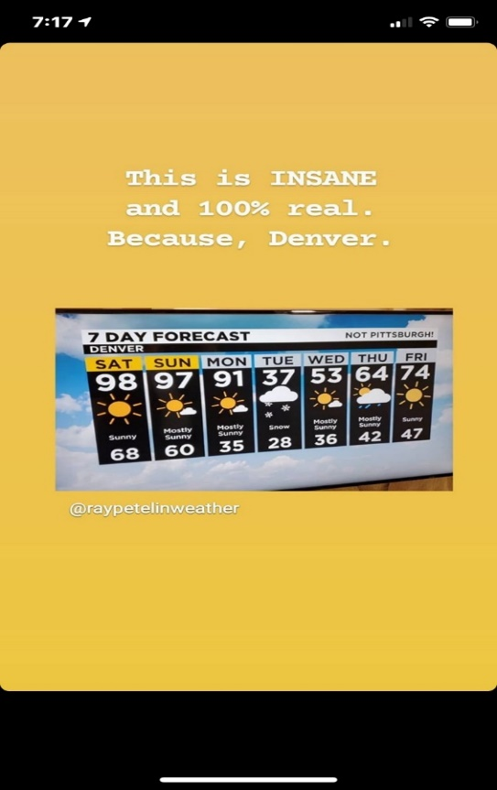

Standards:
Science and Engineering Practices  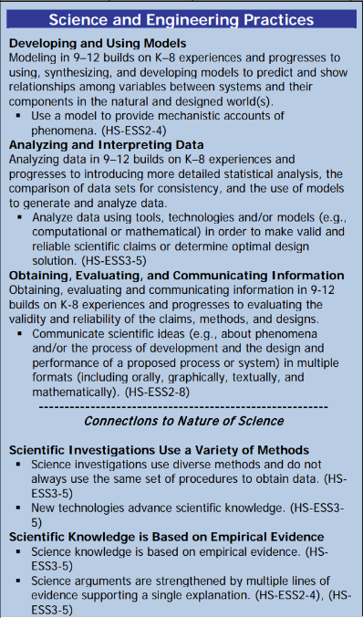 |  |  | Disciplinary Core Idea(s)  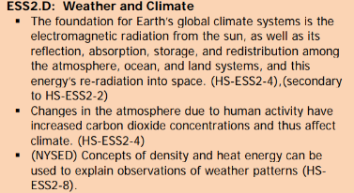 |  |  |  | Cross Cutting Concepts  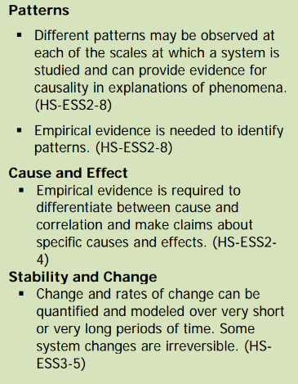
Performance Level
NYS Level 5 | NYS Level 4 |  |  | NYS Level 3 | NYS Level 2 |  |  | NYS Level 1
Collect and analyze global and regional weather data using tools, technologies, and /or models to communicate in multiple formats how the movement and interactions of airmasses result in changes in weather conditions. | Evaluate data and communicate information to explain how the movement and interactions of air masses result in changes in weather conditions |  |  | Evaluate data and communicate information to identify patterns of movement and/or the resulting changes in weather conditions. | Use data to identify the patterns of movement or the interactions of air masses and the resulting change in weather conditions  or to identify factors that drive the movement of air masses or from given weather conditions, identify evidence from maps that support these conditions. |  |  | Use data and/or patterns of movement and interactions of air masses to identify the resulting changes in weather conditions or identify one factor that drives the movement of air masses or from those provided, use evidence from maps to account for weather conditions or given weather conditions, identify evidence found on maps that account for one of these conditions.
Clarification Statement  Examples of evidence sources could include station models, surface weather maps, satellite images, radar and accepted forecast models. Emphasis should focus on communicating how the uneven heating of the Earth’s surface at frontal boundaries and resulting weather phenomena. |  |  |  |  | Assessment Boundary  Analysis is limited to surface weather maps and general weather patterns associated with High and Low pressure systems
Connection to Anchoring Phenomenon:

Frontal passage is a very common event that can be observed by everybody and is essential for weather forecasting.

Essential Question(s):

Describe the properties of the air already in place in the animation.

Describe the properties of the air moving in in the animation.

What do you think a weather “front” is?

What happens along fronts?

Instructional Strategies & Learning Tasks: Engage, Explore, Explain, Elaborate, Evaluate
Engage: images, video clip or data… |  | Students will be asked if they have ever experienced a cold day followed by a warm day or vice versa.  An example is given.  An image of a 5 day forecast of Denver showing temperatures dropping from the 90’s to 30’s in one day.
Explore: Students investigate, experiment, hands-on activity…. |  | Students will observe the weather front animations  They will draw what they see in the animations  For each front the students will brainstorm reasons as to how the fronts get their name.  Students will research the typical type of clouds weather typically associated with each front  Students will predict how the temperature will change with the passage of the frontal boundary, they will also relate the temperature of the air to the type of air mass.
Explain: Students share their observations and evidence to explain their understanding…possible whole group/class discussion… |  | Teacher will elaborate on the different type of fronts as well as how they get their names, common weather associated with the front and the frontal symbols.
Elaborate: Students apply the science concepts they’ve just learned… |  | Students will predict what type of weather will be expected before, during and after frontal passage using the animations knowledge of air masses and common weather associated with each front.
Evaluate (Formative Assessment): Student learning is evaluated. |  | Students will be evaluated based on answers to teachers questions quizzes and tests.

Copy and paste student worksheets below:

